TASK : By using Session Manager Parameter Store creating our domain credentials in a parameter and get these in encryption and decryption formats.

- Create parameter in development level.
- AWS Systems Manager → Parameter Store → /my-app/dev/db-url

- 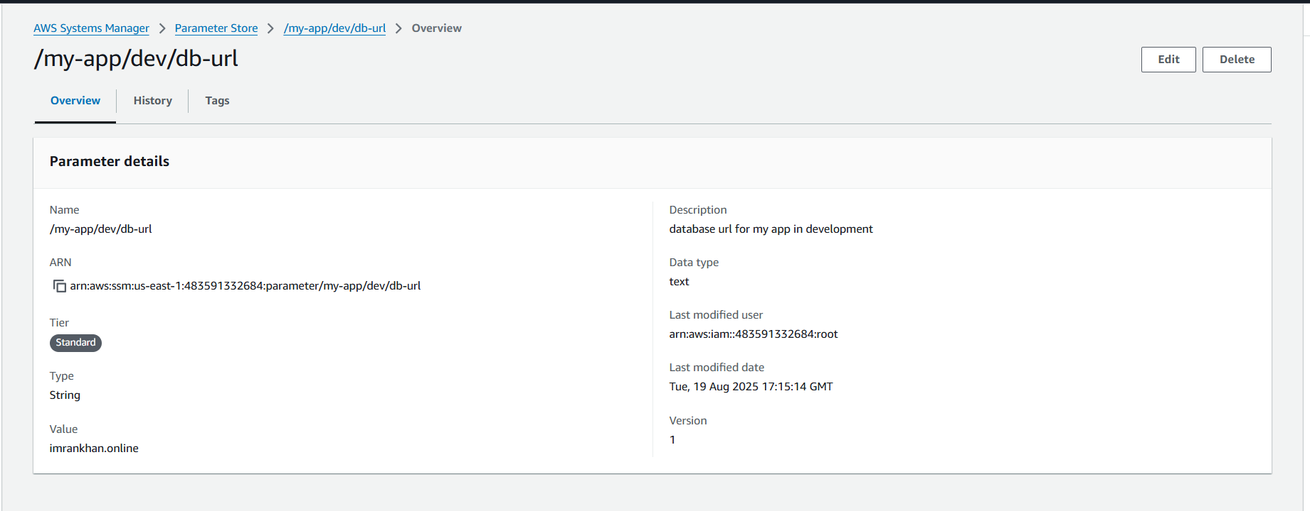
- And create another parameter for app password
- 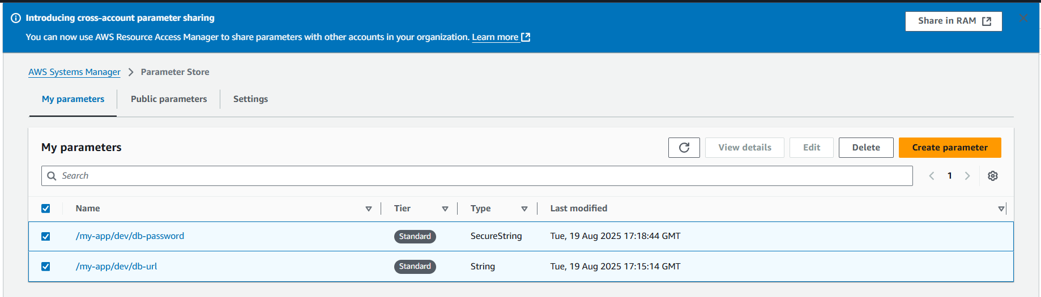
- Creating same in production level also, So total 4 parameters created
- 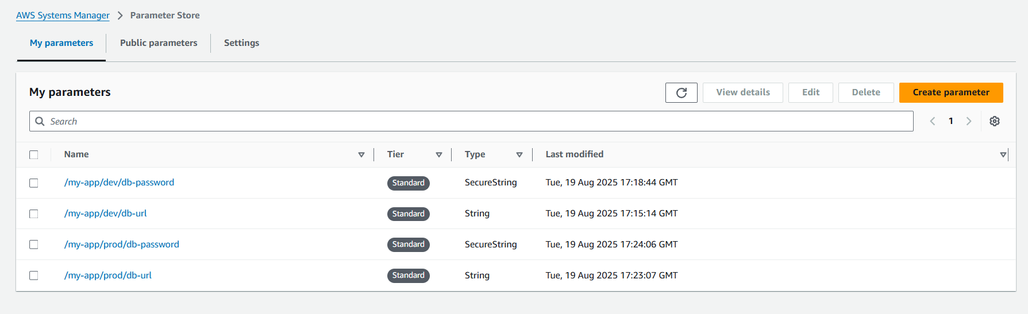
- Open cloudshell cli or any cli and get parameters
- aws ssm get-parameters --names /my-app/dev/db-url /my-app/dev/db-password
- 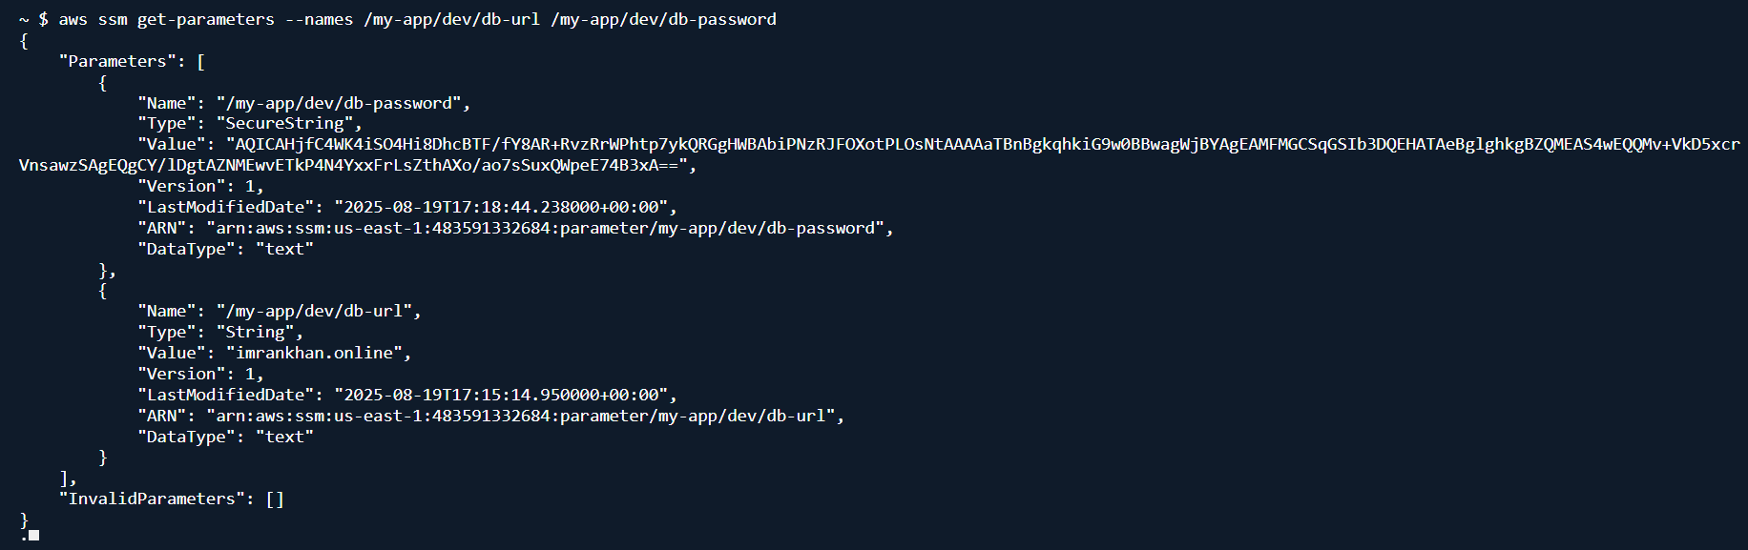
- For string we get plain text but for secure string having password came in encrypted
- Now try to decrypt we can get both url and password in plain text
- aws ssm get-parameters --names /my-app/dev/db-url /my-app/dev/db-password --with-decryption
- 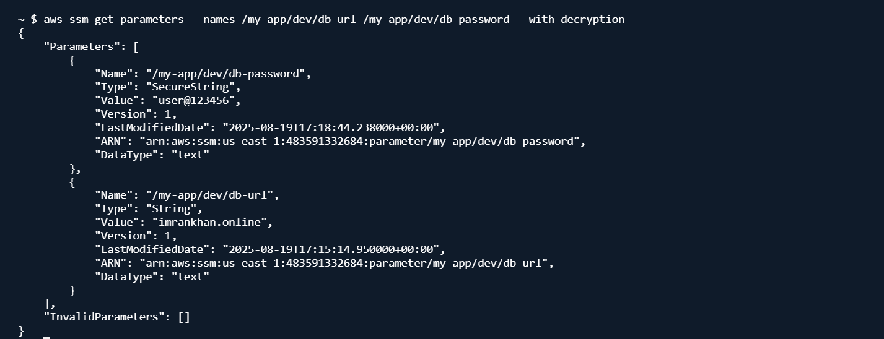
- We can get the parameters by giving path also
- aws ssm get-parameters-by-path --path /my-app/dev
- 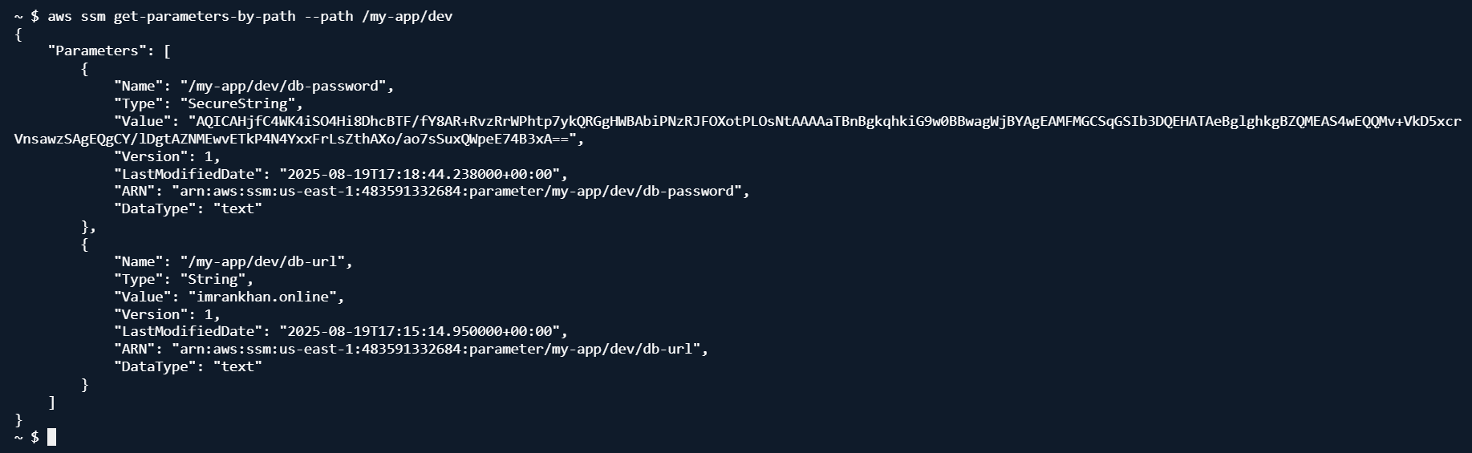
- We can get all parameters using recursive
- aws ssm get-parameters-by-path --path /my-app/ --recursive
- 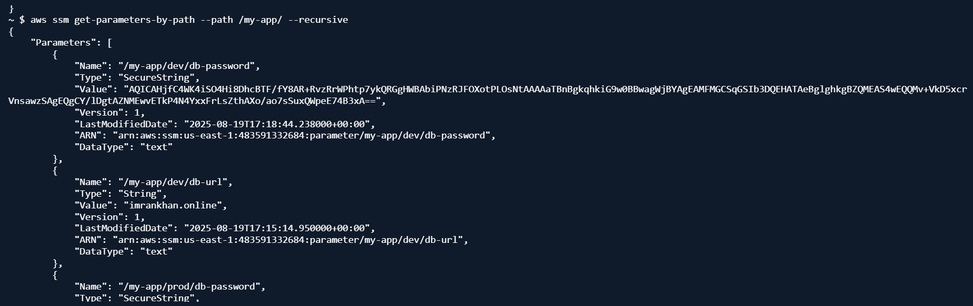
- Now getting all parameters in plain text using recursive decryption.
- aws ssm get-parameters-by-path --path /my-app/ --recursive --with-decryption
- 